**Ideation Phase**

**Brainstorm & Idea Prioritization Template**

|  |  |
| --- | --- |
| Date | 3 October 2022 |
| Team ID | PMT2022TMID17878 |
| Project Name | Exploratory Analysis Of Rainfall Data in India For Agriculture |
| Maximum Marks | 4 Marks |

**Brainstorm & Idea Prioritization Template:**

**Visit: https://app.mural.co/t/goodfour2311/m/goodfour2311/1664759446890/69e856ad90729a2cc0e0f71be20bf34e1d995e06?sender=u0010f56a4c6710dd71586450**

**Step-1: Team Gathering, Collaboration and Select the Problem Statement**

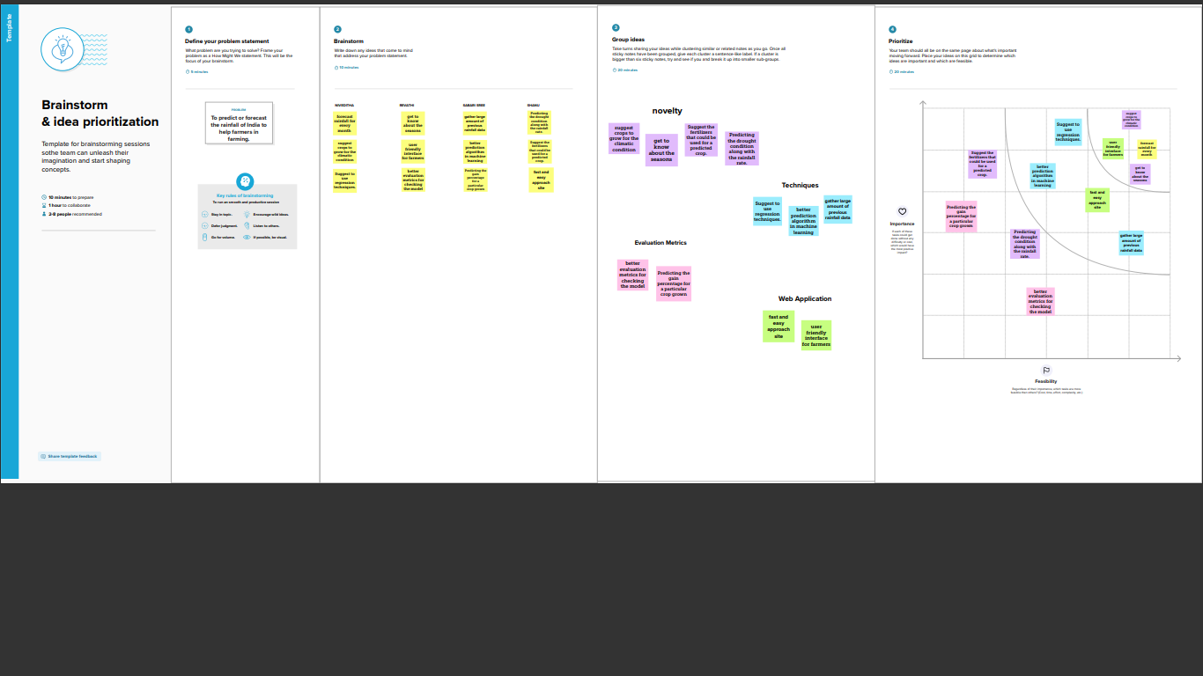

**Step-2: Brainstorm, Idea Listing and Grouping**



**Step-3: Idea Prioritization**

